**3.2 Carbohydrates, lipids and proteins**

**3.2.1 Distinguish between organic and inorganic compounds (2).**

Distinguish means to give the differences between two or more different items.

* Organic compounds are based on carbon and are found in living things. There are a number of exceptions including  
  hydrogen carbonate (HCO3- ), carbon dioxide (CO2 )and Carbon monoxide (CO).
* Inorganic compounds are by default all the molecules other than those in the category above.

**3.2.2 Identify amino acids, glucose, ribose and fatty acids from diagrams showing their structure(2).**

Identify means to find an answer from a given number of possibilities.

The following are examples of the most common organic molecules in living things:

**Monosaccharide sugars**. These are the monomers from which larger polymer molecules are constructed. Molecules like glucose and fructose are metabolically active molecules usually stored in an inactive, insoluble polysaccharide form.

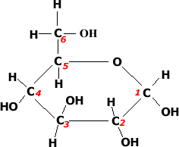

* Glucose: C6H12O6 this is a hexose sugar (six carbons) most commonly found in this ring structure.
* Glucose will be known to most students as a product of photosynthesis or the substrate molecule for respiration.
* Glucose is also found in a polymer as starch, glycogen or cellulose.
* All bonds are covalent.
* Glucose is a reducing sugar and will give positive (Brick red) precipitate in a Benedicts test.
* Glucose is metabolically active compound

Glucose is soluble and has osmotic effects when in solution

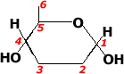This is an alternative diagram of glucose where the carbons are assumed to be at each of the corners or ends of the lines (bonds). In this image the carbons are numbered so you can compare to the diagram above. Normally such numbers would be omitted form a diagram. These shorthand diagrams allow organic molecules to be drawn faster. There are examples further down the page of this type of diagram.

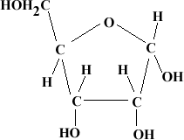

* Ribose: Pentose (5 carbon sugar).
* Ribose is part of one the important organic molecules in photosynthesis, ribulose bisphosphate. (RUBP)
* A modified version of ribose, deoxyribose is perhaps best known for its role in Deoxyribonucleic acid or DNA where it forms part of the sugar phosphate backbone. The chemical properties of deoxyribose are very different from the properties of ribulose
* Both Ribose and Glucose will attract water molecules (hydrogen bonding ) to form solutions.

[top](http://click4biology.info/c4b/3/Chem3.2.htm#top)

**Amino Acids:** There are 20 common amino acids found in the protein structures of living things. Amino acids are monomers which combine to form the larger polypeptides. In turn polypeptides combine to form proteins. Proteins molecules are the basis of enzymes and many cellular and extra cellular components.

* 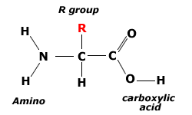

This model shows the structure of the general amino acid. If you build one in a molecular kit you will appreciate better the 3D structure.

* Each of the common amino acids has the same structure as the one shown except that the R group is different.
* Amino acids are soluble

* 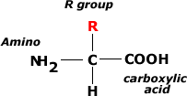

This is an alternative way to draw the general amino acid structure.

* This diagram illustrates the 'amino' group which is -NH2
* There is also the acidic group -COOH which ionizes in solution to form an -COO-and H+groups
* This acid group is known as a carboxylic acid group .

* 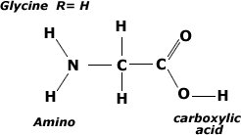

This is an illustration of the smallest of the amino acids, Glycine.

* Notice that Glycine has an amino group, carboxylic acid group and a R group = H
* A common source of glycine is sugar cane.

* 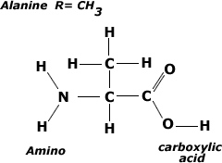

This image shows a common amino acids, Alanine

* Note the similarity in structure with glycine but this time the R group is -CH3
* Students are not required to know the structure of [all 20 common amino acids](http://click4biology.info/c4b/3/aat.htm)

[top](http://click4biology.info/c4b/3/Chem3.2.htm#top)

**Fatty Acids**: These molecules are the basis of triglycerides and many other types of lipid. These molecules are also the basis of the phospholipid molecules that form the bilayer of the cell membrane.

* 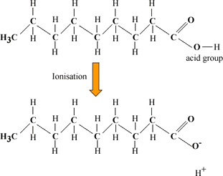

The image shows a basic saturated (no double bonds) fatty acid.

* There is a methyl group (-CH3) at one end of the chain.
* Chain is the formed from a series of covalently bonded carbons saturated with hydrogens.
* The chain is non-polar and hydrophobic
* The carbonyl group is polar making this ends of the molecule hydrophilic.

* http://click4biology.info/c4b/3/images/3.2/fatyacid2.gif

The complex diagram of the fatty acid can be abbreviated to this simpler diagram.

* 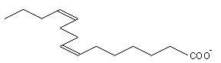

This image show the unsaturated double bond which is characteristic of animal fats.

* If there are many double bonds the fatty acid is known as polyunsaturated.

**Micelle**

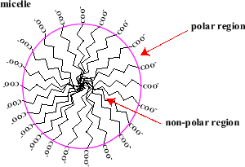[top](http://click4biology.info/c4b/3/Chem3.2.htm#top)

* In water fatty acid molecules arrange themselves into spheres called micelles.
* The polar carbonyl groups on the outside in contact with water molecules.
* The non-polar tail sections are in the centre away from water.
* This is an important aspect of fat digestion and membrane structure.

**3.2.3 List three examples each of monosaccharides, disaccharides and polysaccharides(1)**

List means to Give a sequence of names or other brief answers with no explanation.

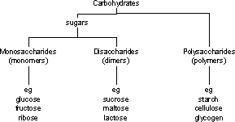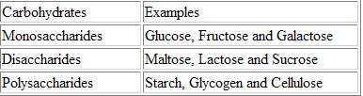

**3.2.4 State one function of glucose, lactose and glycogen in animals, and of fructose, sucrose and cellulose in plants(1)**

State means to give a specific name, value or other brief answer without explanation or calculation.

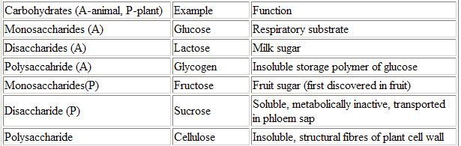

**3.2.5 Outline the role of condensation and hydrolysis in the relationships between monosaccharides, disaccharides and polysaccharides; between fatty acids, glycerol and triglycerides; and between amino acids and polypeptides(2).**

Outline means to give a brief account or summary.

Polymer: consisting of large molecules made up of a linked series of repeated simple molecules called monomers

Monomers: simple molecular units

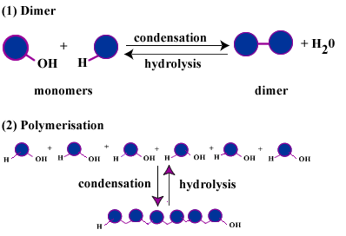Model of polymerisation through condensation reaction.

(1) **Dimers**

a) Two monomers are bonded together to form a dimer.

b) Water (H + OH) are removed to form water.

c) The dimer can be split by hydrolysis but needs water adding

(2)**Polymerisation**

a) In this example six monomers are joined together

b) Polymers normally form more complex shapes than suggested in this model

c) The polymer can be 'digested' back to monomers by hydrolysis reaction

**Formation of a disaccharide (**[**large diagram**](http://click4biology.info/c4b/3/disaccharide.htm)**)**

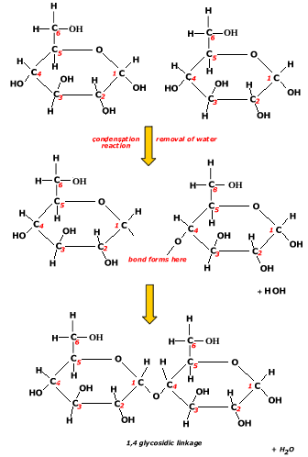a) Two molecule of glucose will polymerise to form maltose

b) The **condensation reaction** will take place between C1 of the first glucose and C4 of the second glucose.

c) A condensation reaction takes place between the glucose 1 (-OH on C1) and Glucose  
(-H on C4).

d) The bond formed is a covalent bond between C1 -O-C4 , called a 1, 4 glycosidic bond.

e) The disaccharide molecule formed is called Maltose which like glucose is a reducing sugar.

f) **Hydrolysis;**The diagram can be reversed so that the disaccharide can be split into two glucose monosaccharides.

g) Hydrolysis is the type of reaction catalysed by the digestive enzymes.

**Laboratory Hydrolysis**

In the lab you can hydrolyse maltose and other disaccharides to their monomers by gentle warming the disaccharide in a dilute Hydrochloric acid.

The test for sucrose has the initial step of acidifying and very gently warming sucrose with an acid before carrying out the Benedicts test.

Sucrose gives a negative benedicts test. However after hydrolysis to glucose and fructose both these sugars give a positive test with Benedicts reagent.

**Formation of a polysaccharide**

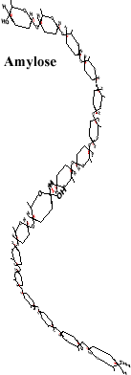**http://click4biology.info/c4b/3/images/3.2/polysacc1.gif**

The above chain of glucose molecules represent the polysaccharide formed by many glucose monomers joining together to form this polysaccharide called amylose.

The molecule to the left represents the helical structure of the polypeptide, amylose.

Amylose is a polymer of glucose.

Intramolecular hydrogen bonding causes the chain molecule to twist into a helical shape.

Amylose is one of two molecules found in starch, the other being a branching polymer of glucose (below)called amylopectin.

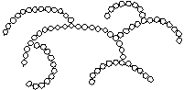Amylopectin

**Starch:** Starch is composed of two polysaccharides, Amylose and amylopectin

Starch is metabolically un-reactive and insoluble and hence an excellent storage carbohydrate.

**Formation of a dipeptide and a polypeptide**

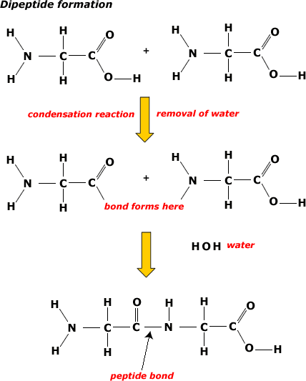

a) Two amino acid monomers of glycine aligned to form a peptides bond by condensation reaction.

b) The peptide bond can form between the carboxyl group of the first amino acid and the amino group of the second amino acid.

d) H-OH or water is removed in the reaction hence the term condensation reaction.

d) Dipeptide is formed (naming system not required) with the characteristic -C-N- bond between the two monomers.

e) Notice that in the dipeptide there is still an amino group at one end and a carboxylic group at the other end.

f) The above pattern is true of all polypeptides and known as the amino terminal and carboxyl terminal of the polypeptide.

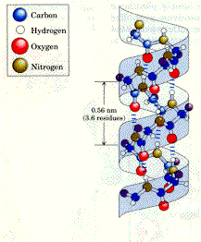Polypeptide chains do not remain as linear (straight) chains. Instead they fold up into the complex yet specific shapes of the protein as seen in this image. The different types of shapes are **not required for SL** but are covered in section [7. 5.1](http://click4biology.info/c4b/3/chem7.5.htm)

The shape of a protein is determined by intra-molecular hydrogen bonding and some covalent bonding between R groups (-S-S-, disulphide bridges).

Polypeptides can be hydrolysed in the same way as polysaccharides with by incubating with acids. Naturally polypeptides are digested by a group of enzymes called Peptidases which hydrolyse the chain into amino acids.

**Formation of a triglyceride:**

Chemically all fats and oils are triglycerides (simple lipids). Fats are those lipids which are solid state at 20oC. Oils are those lipids which are liquid at 20oC. Oils with unsaturated fatty acids have bends in their tail structure which reduces the density of the molecule and lowers its melting point. Oil also tend to have short fatty acid tails. Conversely fats tend to have longer fatty acids with saturated bonds. This makes their structure densely packed and raises the melting point.

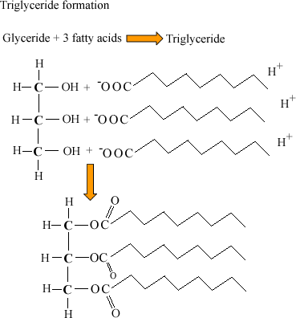

* The formation of a triglyceride or any lipid is **not a polymerisation** like the previous examples.
* Instead three fatty acids chains (usually of different length) are bonded to the molecule glycerol.
* Ester bonds (**-O-**) are formed between an -OH group on the glycerol molecule and the carboxylic acid group (-COOH) of the fatty acid.
* The triglyceride formed is insoluble. (Hydrophobic).
* Fatty acid tails can vary in length and may contain unsaturated bonds
* Animals fats have saturated fatty acids which are straight molecules and very compact. This is gives them a higher melting point than the plant oils
* Plant oils have unsaturated and polyunsaturated fatty acid chains that tend to branch and make the molecule less dense and with a lower melting point.

**Phospholipids**are the principle molecule in the cell membrane they form the 'bilayer' that is the cell membrane.

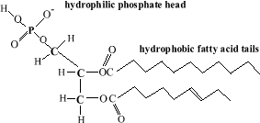Phospholipid structure:

* Very similar to the triglyceride except one fatty acid chain is replaced by a polar phosphate group. The molecule is in two parts

a) Polar hydrophilic phosphate heads.

b) 2 Non polar hydrophobic tails

* 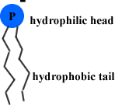

This diagram is a short hand version of the phospholipid molecule.

* It illustrates the negatively charged hydrophilic head and the hydrophobic tails
* Often additional groups are attached to the negative head such as Choline, Serine or Inositol

**3.2.6 State three functions of lipids(1).**

State means to give a specific name, value or other brief answer without explanation or calculation.

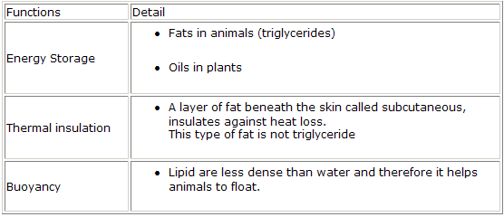

**3.2.7 Compare the use of carbohydrates and lipids in energy storage(3).**

Compare means to give an account of similarities and differences between two (or more) items, referring to both (all) of them throughout.

